Name: Display the list of File Imports

Trigger: User Interaction with CMS window

Precondition:

1. Assert that user has logged in

Path:

1. User clicks on import from the Admin drop down menu.

Requirements:

1. List of imported files should be displayed with status and created date

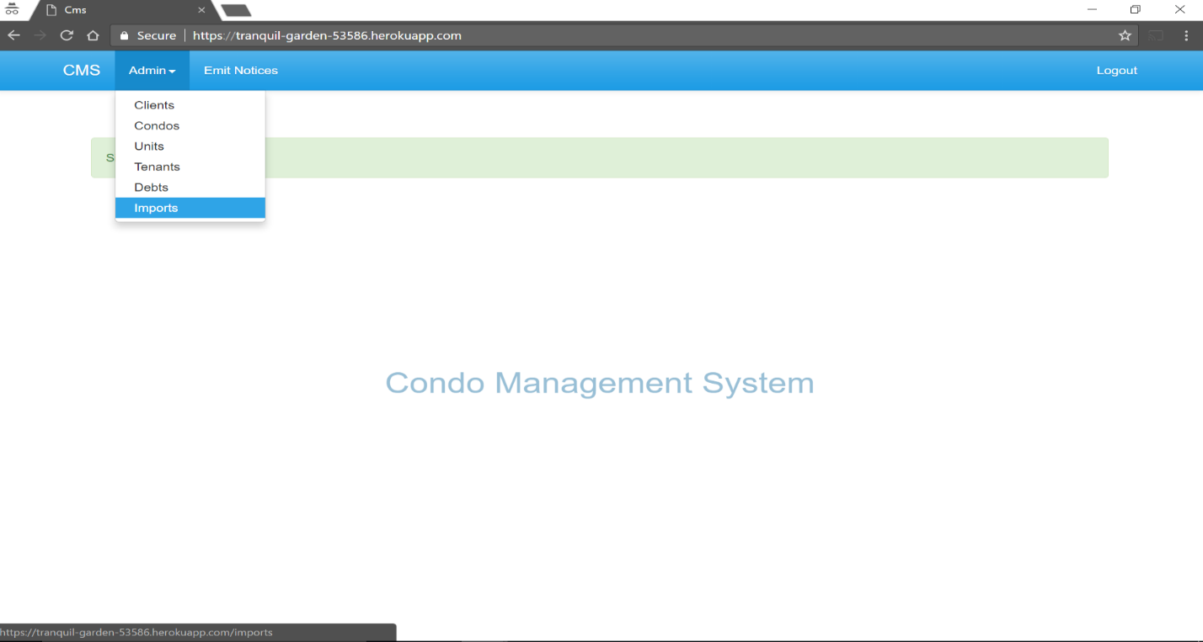

List of imported files:

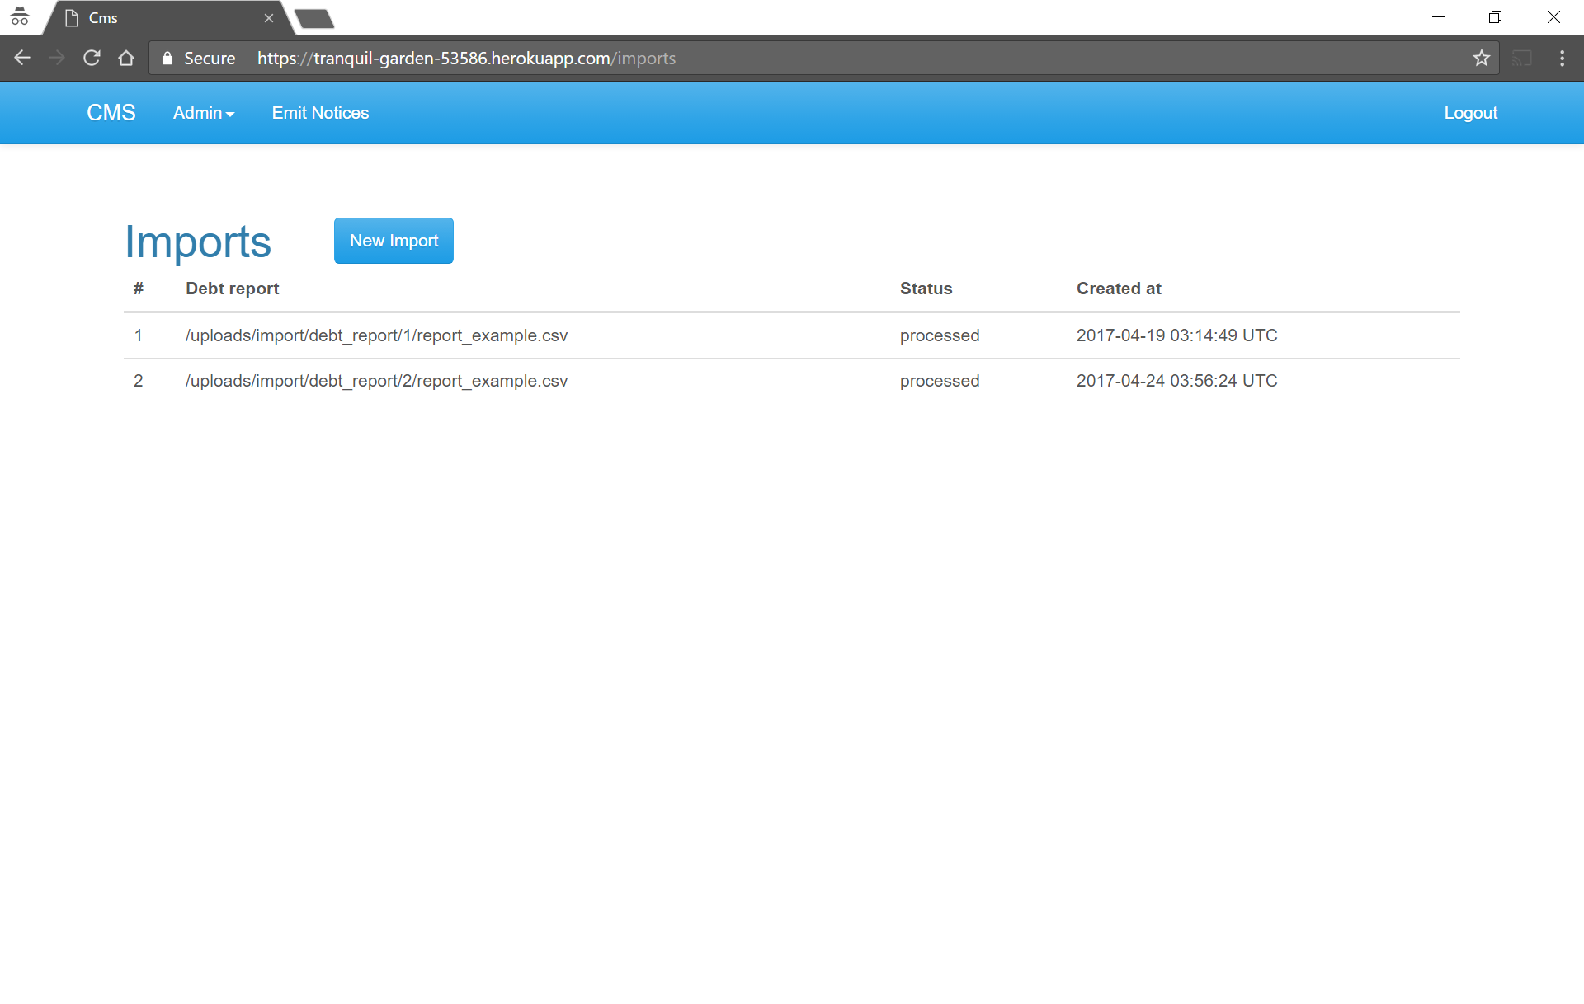

Name: Create New Import

Trigger: User Interaction with CMS window

Precondition:

1. Assert that user has logged in

2. User should have a file in a pre-defined format for import and it should have all clients, condos, units, tenants and debts listed in the file

Path:

1. User clicks on import from the Admin drop down menu.

2. User clicks on New Import from new screen

3. User chooses file from system by clicking Choose File

4. User should be able to see uploaded file and click Create Import

Requirements:

1. List of imported file should be displayed with status and created date
2. On New Import, the upload window should appear to choose the file from system
3. On Create Import, updated list of file should be displayed.

Choose file

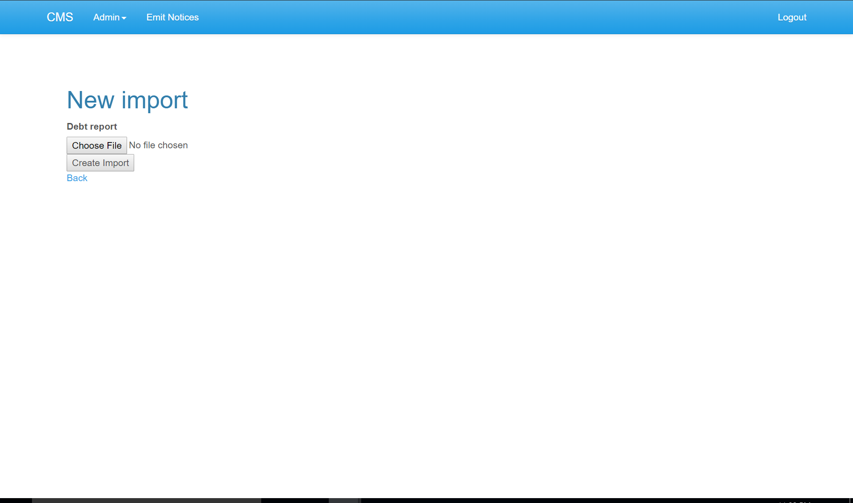

Attach file

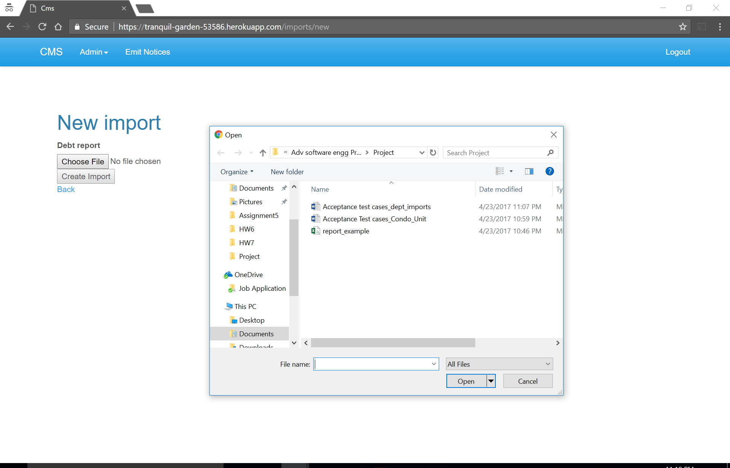

Create import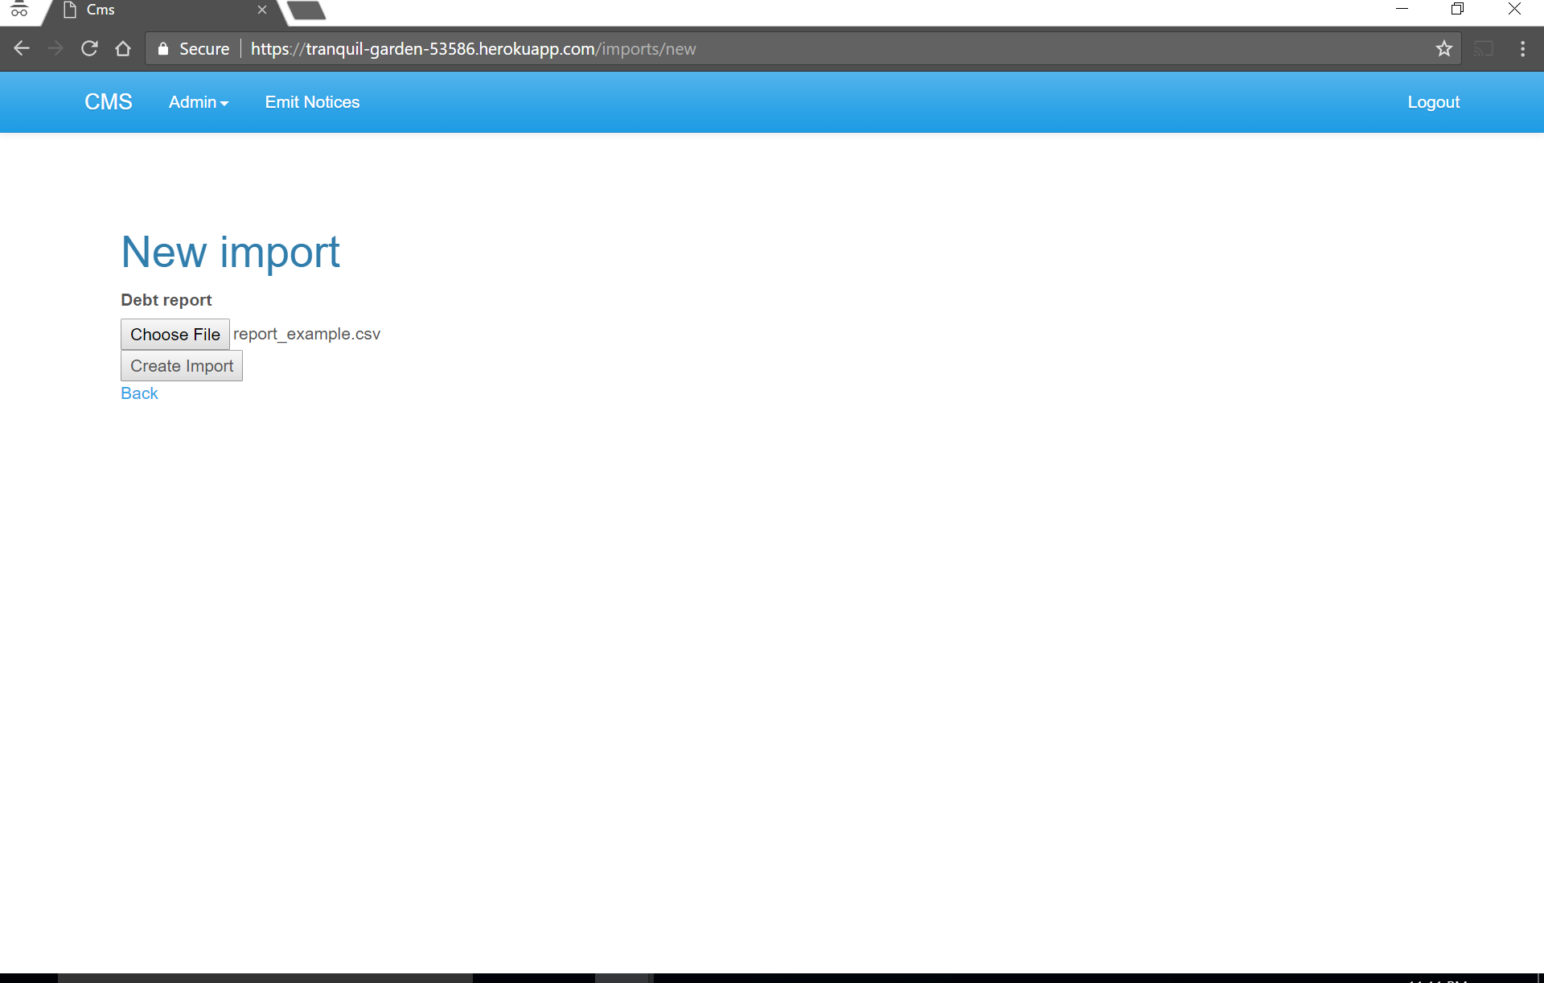

Imported file

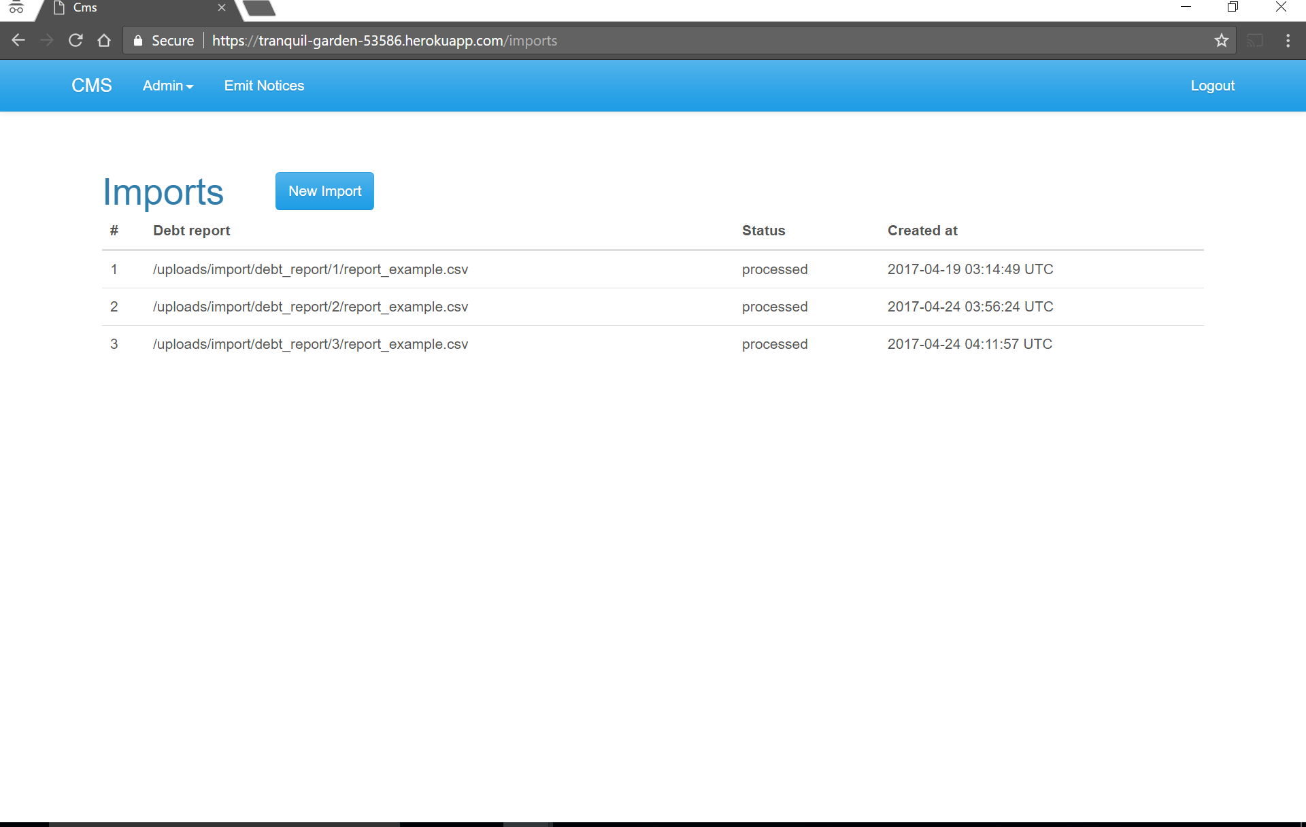

Error after import file with deleted row

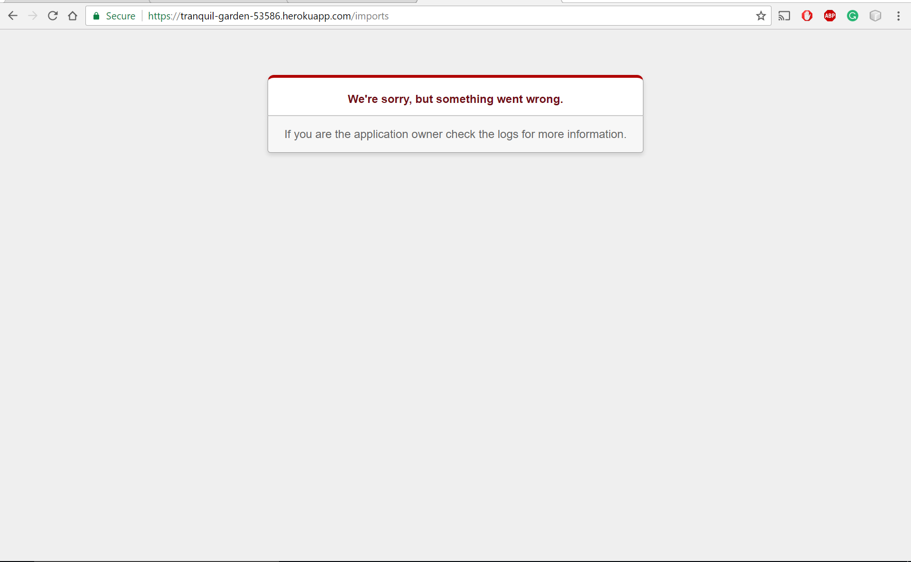

Name: display the list of Debts

Trigger: User Interaction with CMS window

Precondition:

1. Assert that user has logged in

Path:

2. User clicks on Debts from the Admin drop down menu.

Requirements:

3. List all debts should be displayed with edit and destroy option

Debts:

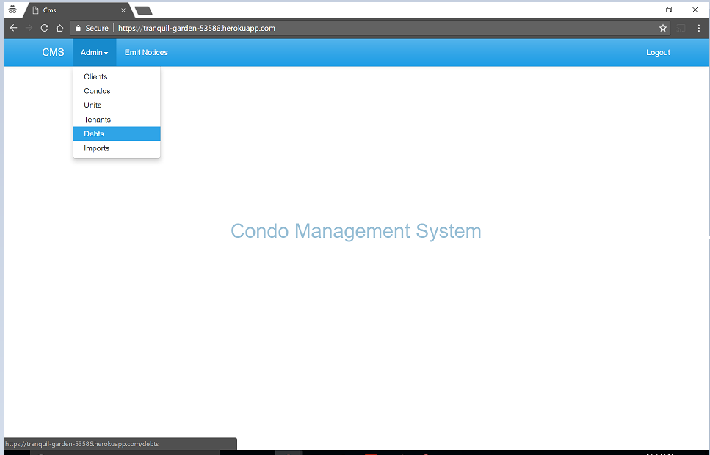

List of debts and add new debts

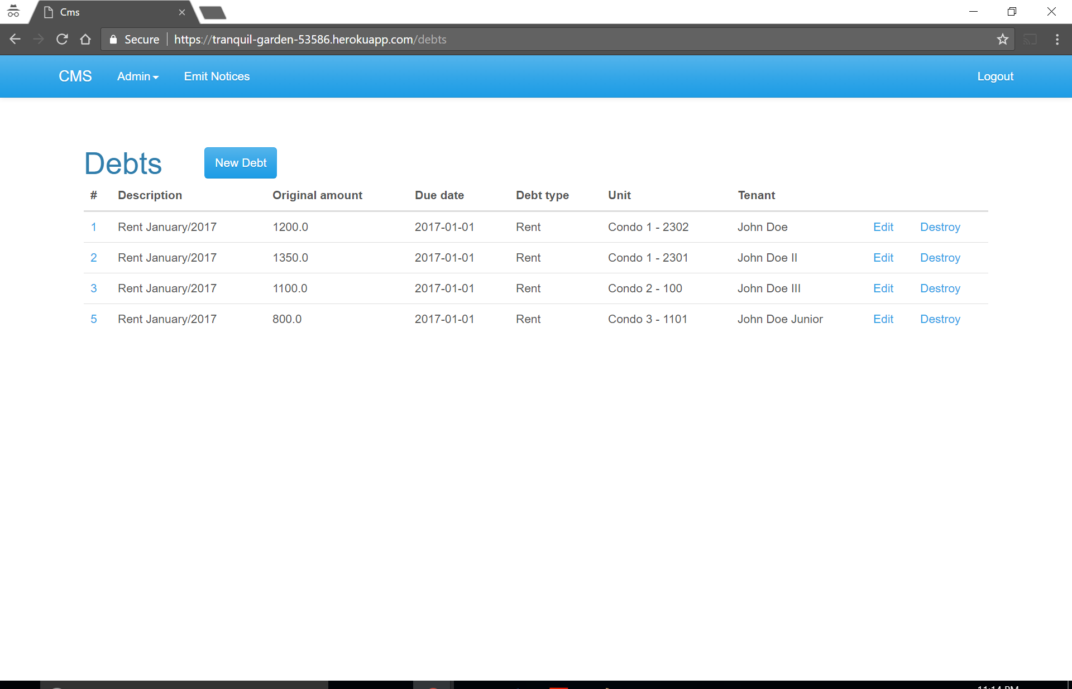

Name: Create New Debts

Trigger: User Interaction with CMS window

Precondition:

1. Assert that user has logged in

Path:

1. User clicks on Debts from the Admin drop down menu.

2. User clicks on New Debts in new screen

3. User enters required information in given field

4. User clicks Create Debts after entering required data

Requirements:

1. After creating debts system should display the message of successful creation of debts

Enter data:

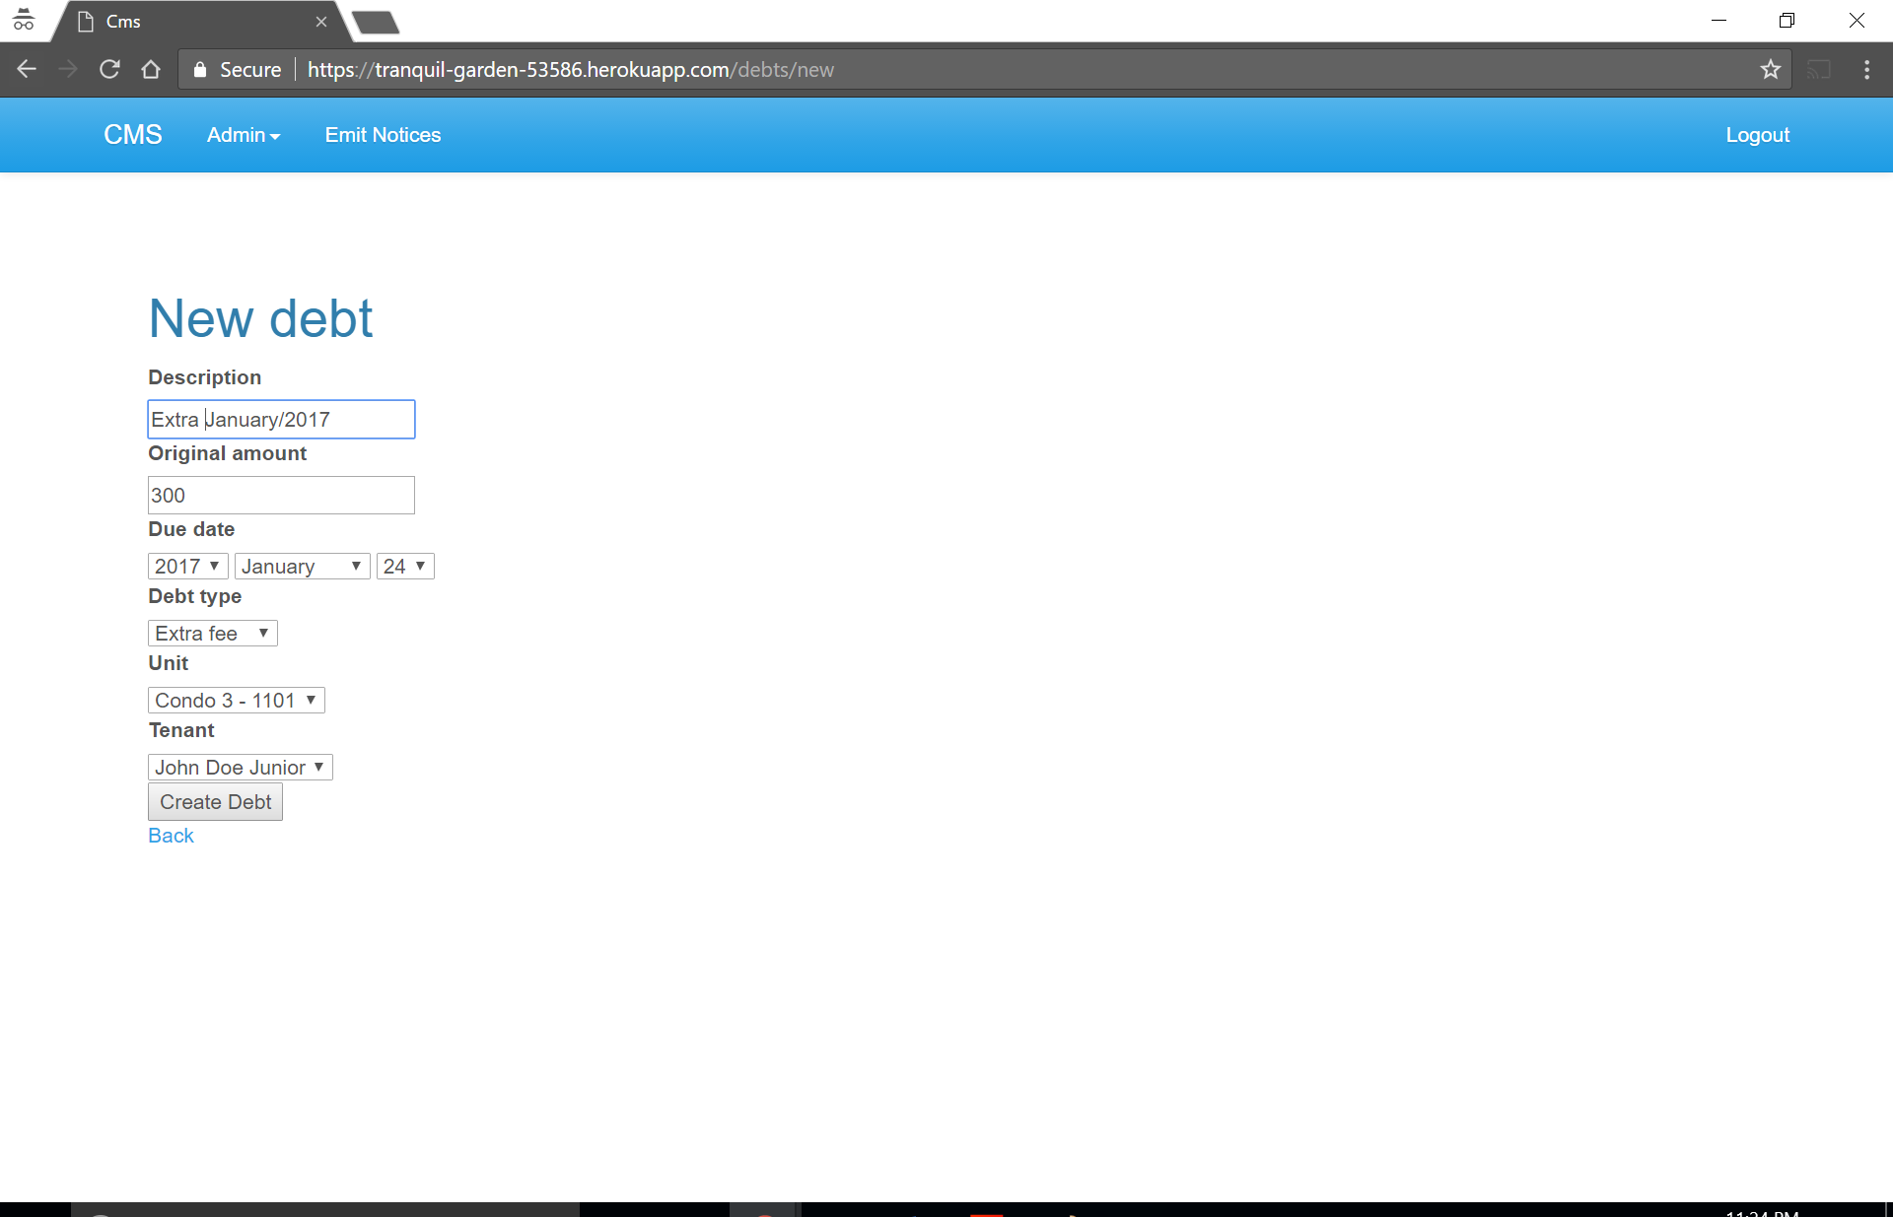

Successfully created new debt

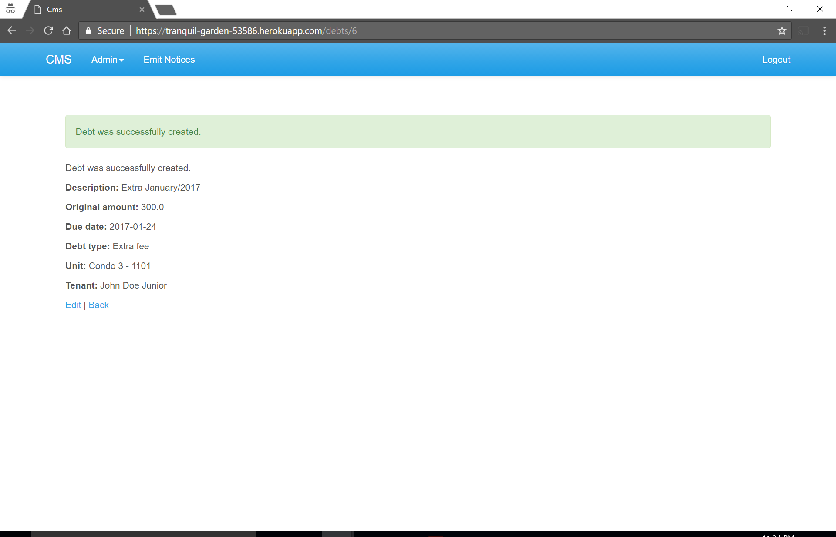

Name: Edit the debts

Trigger: User Interaction with CMS window

Precondition:

1. Assert that user has logged in

2. List of debts should be present for editing

Path:

1. User clicks on Debts from the Admin drop down menu.

2. User clicks on edit in particular row

3. User changes required information in given field

4. User clicks Update Debts after changing required data

Requirements:

1. After updating debts system should display the message of successful update of debts

2. Updated list of debts with new data should be displayed

List od debts:

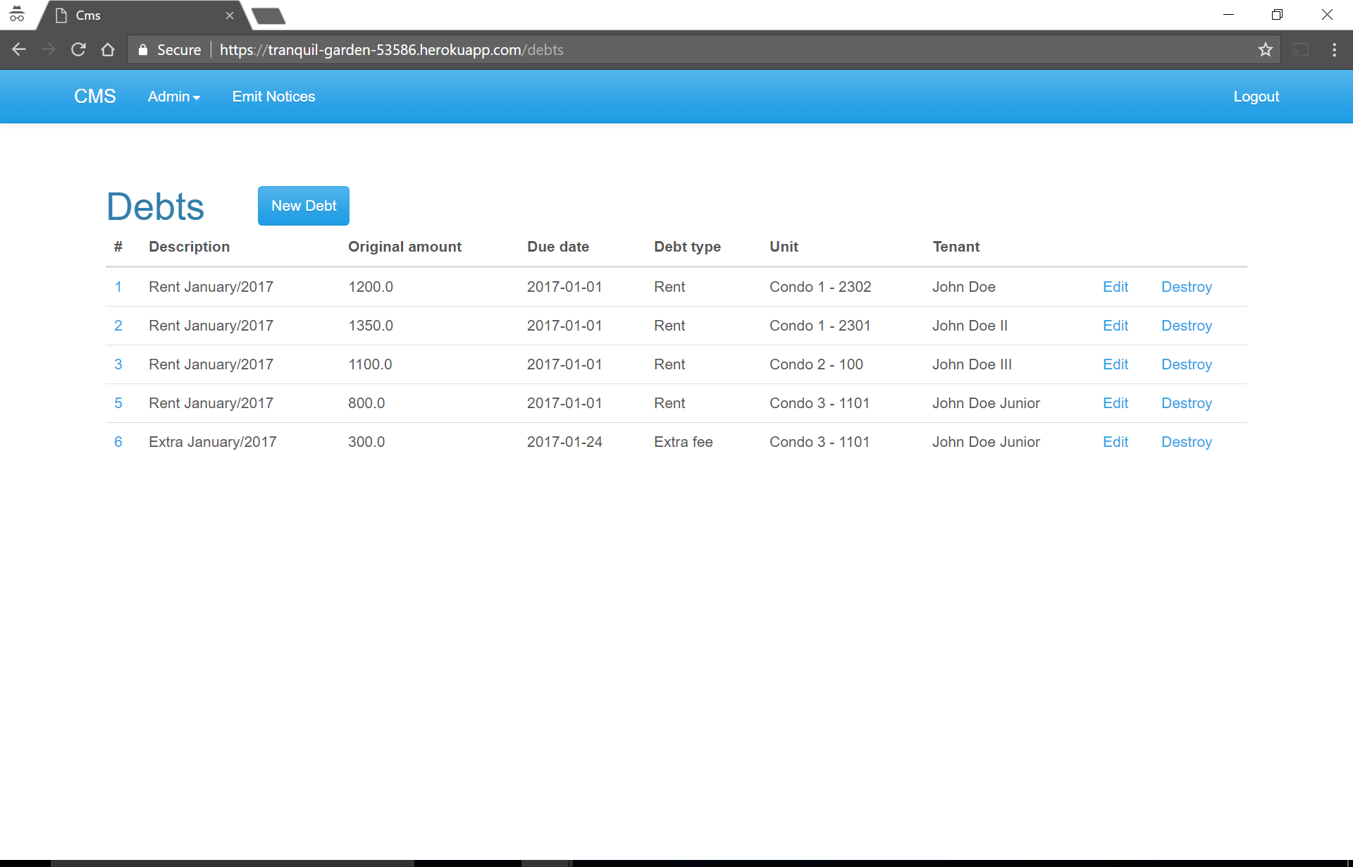

Update debt

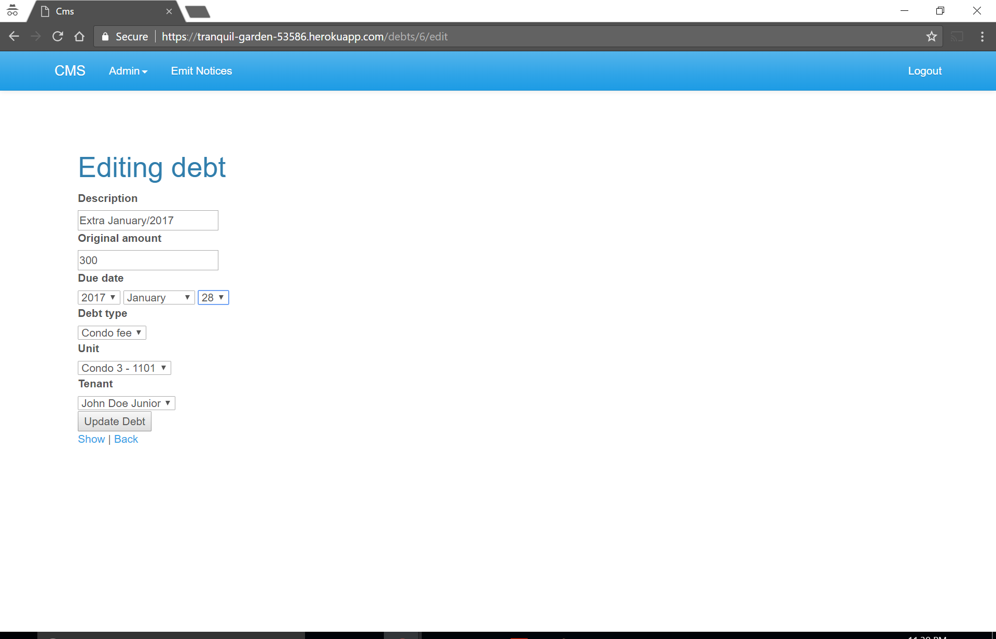

Successful update

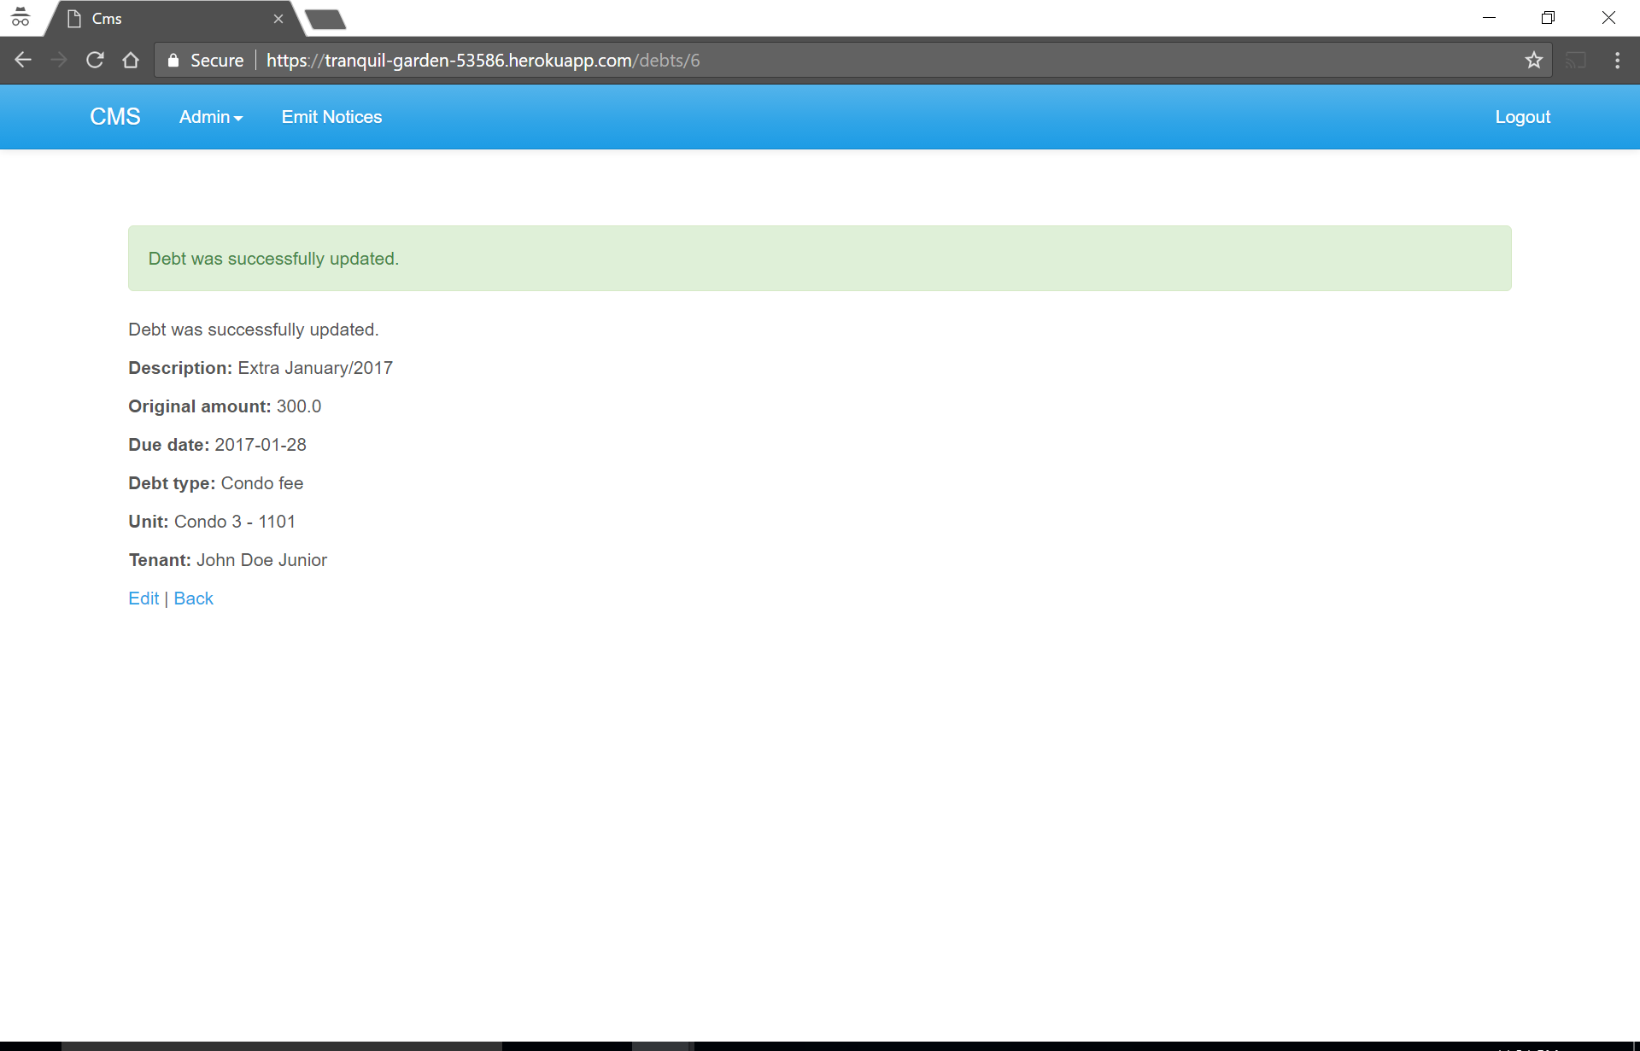

New update in list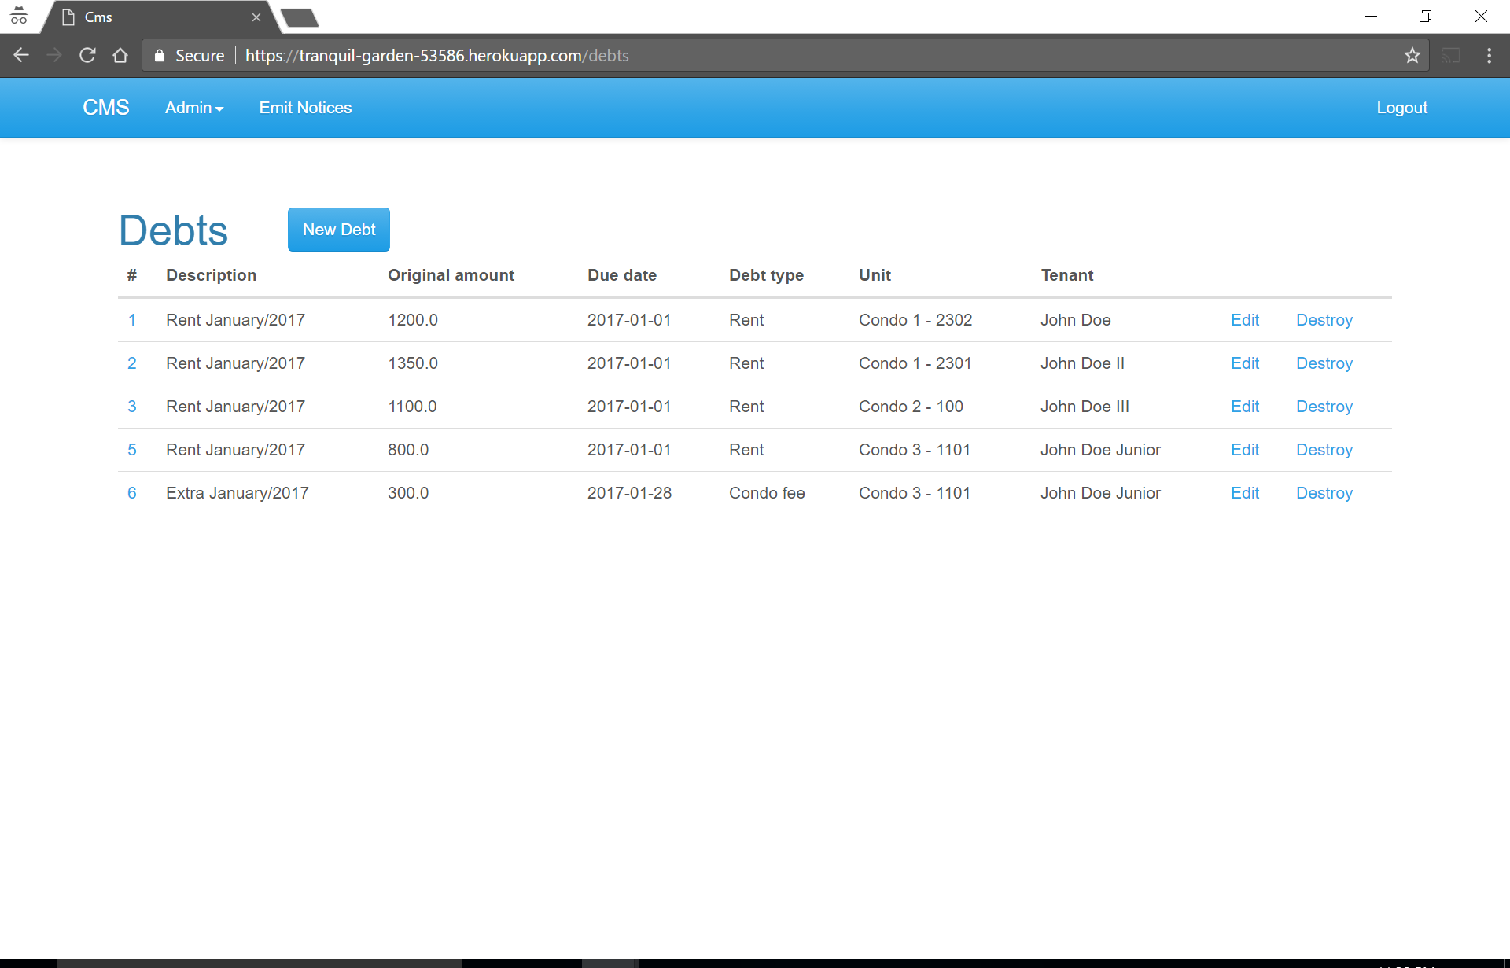

Name: Delete the debts record

Trigger: User Interaction with CMS window

Precondition:

1. Assert that user has logged in

2. List of debts should be present for deleting

Path:

1. User clicks on Debts from the Admin drop down menu.

2. User clicks on Destroy in particular row

3. User clicks OK on new confirmation dialog window

Requirements:

1. After destroying debts record, system should display the message of successful destroyed of record

2. Updated list of debts should be displayed

Delete:

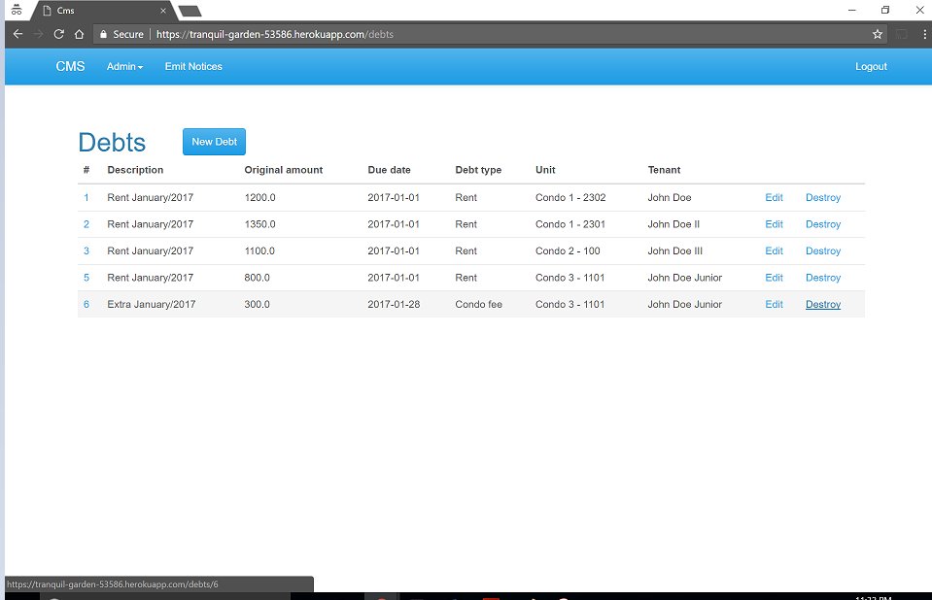

Delete alert:

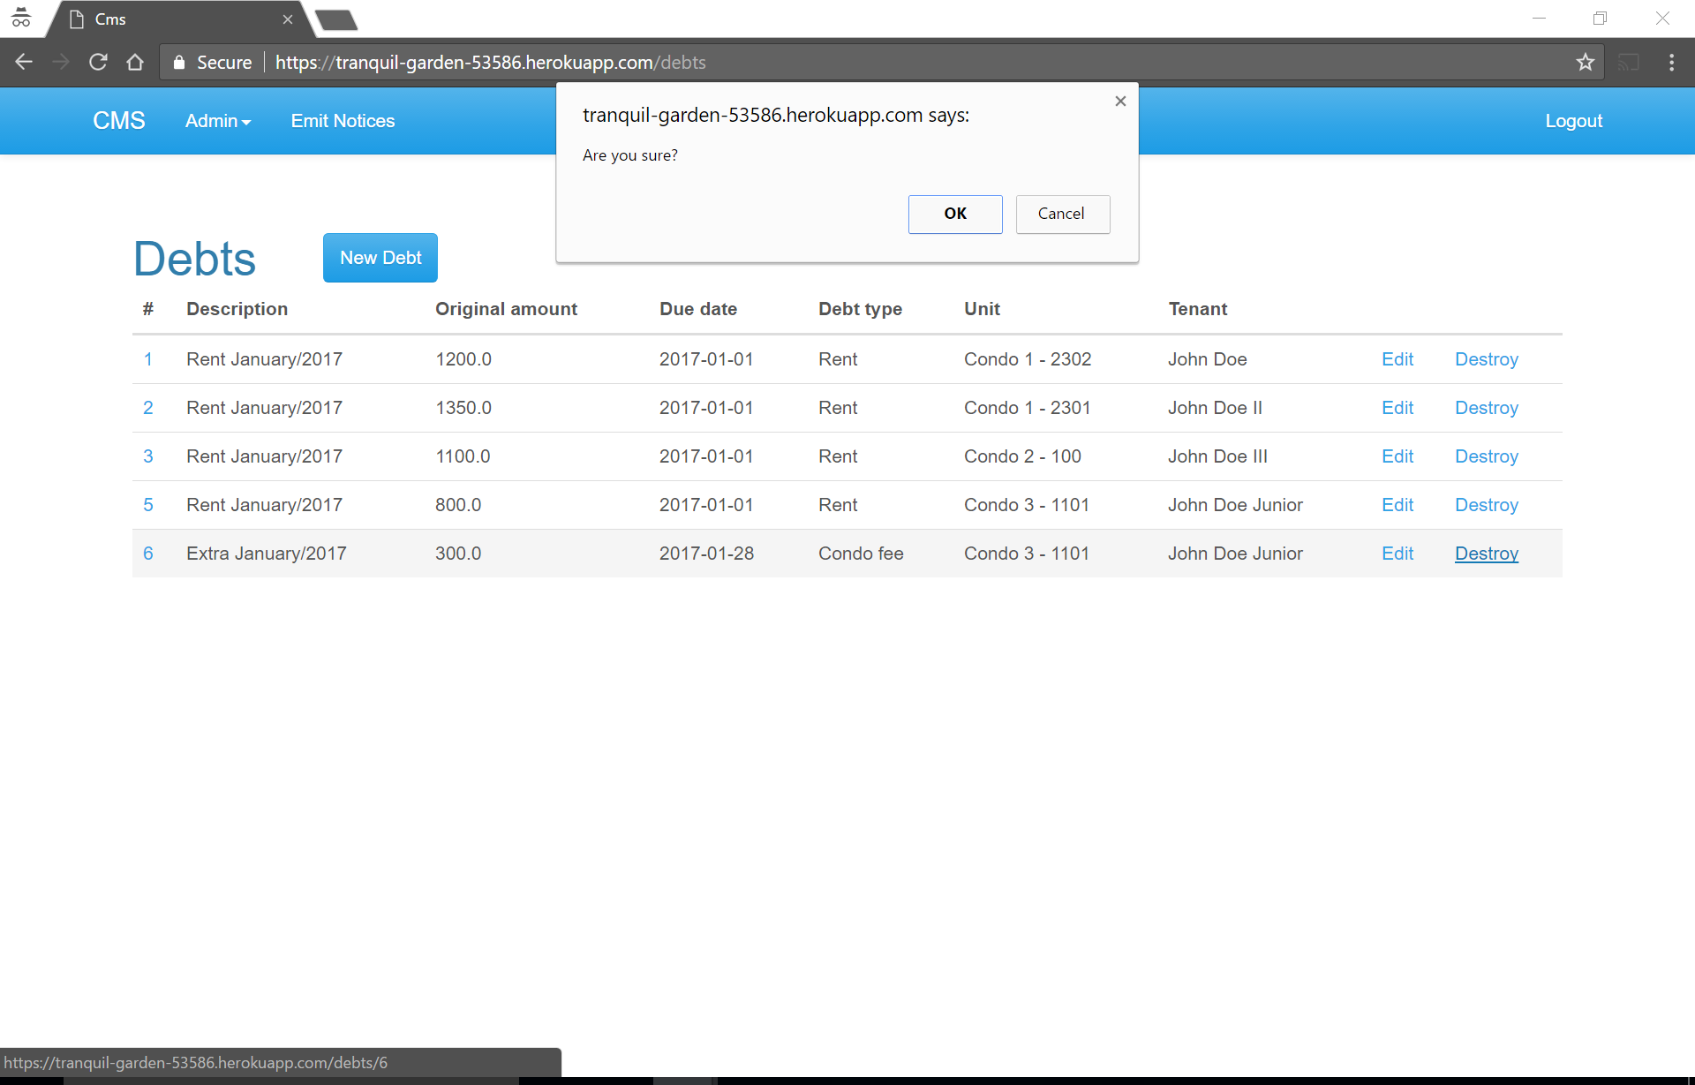

New list: